**PresTo: A liquid-filled camera for low-cost imaging in the deep sea**

Breanna E. Motsenbocker a,*, Timothy J. Noyes c, d, Alexandra T. Runyan a, Russell Shomberg a, Brennan T. Phillips a, b

a *University of Rhode Island, Department of Ocean Engineering, 215 South Ferry Rd., Narragansett, RI, USA*

b *University of Rhode Island, Graduate School of Oceanography, Narragansett, RI, USA*

c *Bermuda Institute of Ocean Sciences, Arizona State University, St. George’s, Bermuda*

d *University of Salford, Manchester, UK*

*\** Corresponding author. University of Rhode Island, Department of Ocean Engineering, 215 South Ferry Road, Narragansett, RI, USA. *Email address:* [*bmotsenbocker@uri.edu*](mailto:bmotsenbocker@uri.edu)

**Abstract**

Deep-sea imaging systems are traditionally expensive to manufacture and are physically scaled depending on the operating depth of their housing and the internal camera/lens components. Liquid and epoxy filled instrument designs are increasing in popularity as a way to reduce the cost and size of deep-sea housings. Recent advances in 3D printing have facilitated rapid prototyping of these pressure tolerant deep-sea designs. This study presents the design of PresTo, a liquid-filled pressure tolerant camera manufactured using SLA 3D printing methods. This is a compact and low-cost imaging system filled with deionized water and coated in epoxy to remove all implodable air volumes in the camera. The lens design for PresTo can be easily customized to any focal length and with zoom capabilities using a magnetically driven focus mechanism. Images taken with PresTo likely have minimal image distortions compared to other underwater cameras with flat viewports because, due to the elimination of a flat viewport solely for the reason of pressure isolation, there is an inherent reduction in the refractive indices of the surrounding environment and internal medium. The presented system has been field-tested to depths exceeding 1700 meters and has been hydrostatically tested to function beyond 2600 meters.

*Keywords:* Deep-sea imaging, pressure tolerant, 3D printing, image distortion

**1. Introduction**

Traditional deep-sea cameras require a 1-atmosphere dry housing that is made of strong metals (e.g., aluminum, stainless steel, titanium) and with a sealed flat or dome viewport made of acrylic, glass, or sapphire. The size and cost of these cameras increases significantly depending on the desired operating depth. Recent advances in marine technology have been focused on developing smaller, low-cost cameras to make deep-sea research and exploration more accessible (Cazenave et al., 2015; Marshall et al., 2007; Phillips et al., 2019b). However, these cameras are still pressure sensitive due to the implodable air volumes within the housing and camera.

Liquid filling deep-sea housings and electronics is a common method for designing pressure tolerant technology (Kampmann et al., 2012; Thiede et al., 2009). There have been previous studies on the design of liquid-filled cameras (Gelze & Lehr, 2011; Holzschuh, 1978), but it is not commonly done because changing the medium inside the lens has a significant impact on the optical pathways of light, and limited liquid options exist that are both dielectric and optically clear. For any liquid-filled camera, a custom lens must be made which may not be economically feasible based on the optical ray tracing software required and the cost of manufacturing prototypes. The use of 3D printing has increased in popularity for deep-sea technology because of the strength and variety of materials for rapid, low-cost prototyping (Breddermann et al., 2016; Mohammed, 2016; Vogt et al., 2018).

Another benefit to a liquid-filled camera relates to image distortion which is a common concern with underwater cameras. Traditional underwater cameras with a flat viewport experience an increase in radial and translational distortions due to the change in the index of refraction (IOR) from the external medium, seawater, to the internal medium, air (Maas, 1995; Treibitz et al., 2012). Using a dome port can reduce these distortions, but integrating a dome port into an underwater housing is expensive and often difficult to manufacture (Menna et al., 2016). By filling the camera lens with water, the difference in the IOR between the external and internal mediua is minimal and distortions can be reduced without taking a dome viewport design into consideration.

This paper describes the design and application of PresTo, a liquid-filled, pressure tolerant camera for deep-sea research and exploration. PresTo is manufactured with SLA 3D printing and can be easily integrated into underwater vehicles, baited remote underwater video systems (BRUVs), and other deep-sea technology due to its small form factor and customizability. PresTo also has the advantage of reducing image distortions without the use of a dome port. Laboratory testing and field deployments of PresTo are also presented in this study, including imagery of deep-sea animals at depths exceeding 1700 meters.

**2. Methods**

Optical ray tracing for the lens design was calculated using Python. The code is available open source via Github (<https://github.com/URIL-Group/PresTo>). This program calculates the effective focal length (EFL), field of view (FOV), and aperture of any lens configuration in any medium. Each cavity of liquid between glass lenses is treated as its own lens, referred to as a liquid lens. The focal length of each liquid lens was calculated using the thick Lens-Maker’s equation (Eqn. 1) (Morgan & Hanau, 1953).

$\frac{1}{f}=\left(\frac{n_{l}}{n_{m}}-1\right)\left[\frac{1}{R_{1}}-\frac{1}{R_{2}}+\frac{d\left(\frac{n_{l}}{n_{m}}-1\right)}{n_{l}R_{1}R_{2}}\right]$*Equation 1.*

Where $n_{l}$ is the refractive index of the lens, $n_{m}$ is the refractive index of the medium, $R_{1}$ is the radius of curvature closest to the incoming light (mm), $R_{2}$ is the radius of curvature closest to the sensor (mm), $d$ is the thickness of the lens (mm), and $f$ is the EFL (mm). This calculation was used in conjunction with OpticalRayTracer (Lutus, 2017), an open-source Java program for designing lenses and mirrors, to visualize the optical pathways of the lens assembly.

The overall system design of PresTo was based around the chosen optical configuration. This included an 8 MP Sony IMX219 sensor from a Raspberry Pi v2 camera module. The factory-installed lens and IR filter were removed from the camera module, leaving it with a bare CMOS sensor mounted on the PCB. Other components of PresTo (sensor/PCB case, lens chamber, lens holder and screw cap) were 3D printed with a Formlabs SLA-based printer using black standard resin. The 3D printed case for the PCB and sensor was filled with Crystal ClearTM 200 epoxy that was cured in an elevated pressure environment (approximately 2-3 atmospheres above ambient pressure) to remove air bubbles. This protects the electronic components from the liquid inside the lens and from the ambient pressure. The epoxy filled system was X-rayed at the University of Rhode Island (URI) campus to confirm all air bubbles were removed. This step was necessary because the use of black resin for the 3D printed parts made it impossible to visually inspect the epoxy.

PresTo was calibrated with photos of a 23 cm x 18 cm checkerboard taken at two distances in air and in water. This was also done with a DEEPi camera (Phillips et al., 2019b) to compare image quality and distortions between these cameras. The DEEPi camera has a traditional air-filled lens with a flat viewport and uses the same imaging sensor as PresTo. At least 30 images were taken at each range with each camera and these images were processed using Python OpenCV (Bradski, G. 2000) to confirm lens properties and determine distortion coefficients.

PresTo was pressure tested in a hydrostatic pressure chamber. Recorded video footage from PresTo was taken inside the chamber to verify functionality during pressure testing. PresTo has also been deployed 5 times in the field with SCUBA divers for shallow deployment and via BRUV for deep deployment. The BRUV used in this study had two LED lights, a glass sphere for floatation, a battery housing, and an Edgetech acoustic release (Phillips et al., 2019a). Shallow deployments took place in Rhode Island in October 2022. Deep deployments took place approximately 10 km off the Northeast coast of Bermuda in November 2022.

**3. Results**

*3.1 System Design*

The liquid-filled lens designed for PresTo has a focal length of 8.0 mm, a horizontal field of view of 26°, and an aperture of 1.78. The assembly consists of one double convex lens with an IOR of 1.67 and one achromatic lens. The achromatic lens consists of two lenses cemented together that have an IOR of 1.67 and 1.78. The liquid inside the lens is deionized water which has an IOR of 1.33. Visualization of the optical pathways through the glass and liquid lenses from OpticalRayTracer can be seen in Fig. 1. The lens described here can be modified to achieve different focal lengths or to enable zoom capabilities.

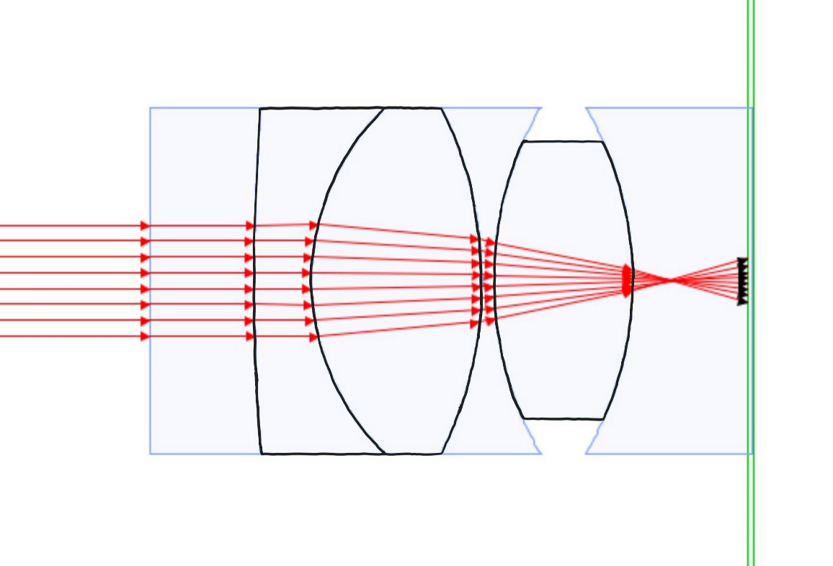**Fig. 1.** Optical ray tracing of the lens assembly created in OpticalRayTracer (Lutus, 2017). Glass lenses are outlined in black, liquid lenses are outlined in blue

There are four 3D printed components in the system design: the PCB/sensor case, lens chamber, lens holder, and screw cap (Fig. 2a). The PCB/sensor case contains the Raspberry Pi v2 camera module PCB and CMOS sensor is filled with Crystal ClearTM 200 epoxy (Fig. 2b). Protecting these components with clear epoxy allows the user to choose any liquid to fill the lens chamber while maintaining a clear image. The lens chamber is attached to the case using clear J-B Weld. The glass lenses are placed inside the lens holder which is designed to have small tolerances to keep the lenses securely in place. There are 4 slots in the lens holder for steel pins. These pins can be driven using a magnet on the outside of the chamber to rotate the lens holder. The lens holder and lens chamber have external threads printed on them, so the rotation of the lens holder translates to linear motion in and out of the chamber for focusing (Fig. 2a). There is a thin optical viewport on the end of the lens chamber that is compressed against an O-ring with the screw cap to seal the internal volume. Lastly, a flexible tube is attached to the lens chamber to act as a passive pressure compensator for the internal fluid. To fill the lens chamber and ensure the removal of all air bubbles, the entire assembly is submerged in the liquid and sealed. The total internal volume of the system is approximately 25 mL. A patent application has been filed covering the design and features of PresTo.

For laboratory testing and field deployments, PresTo was integrated into the endcap of a 1-atm, SLA-printed dry housing (Fig. 2c). The endcap was designed with an opening for the PCB case. This opening was reinforced and sealed with epoxy which allowed for a ribbon cable pass-through into the body of the housing. This dry housing contained a battery and a Raspberry Pi Zero W computer which makes it a self-contained system that can be interfaced via Wi-Fi on the surface. The Zero W was programmed with an open-source library that enables the camera to take continuous video (<https://github.com/URIL-Group/deepi-python>).

**(c)**

**(b)**

**(a)**

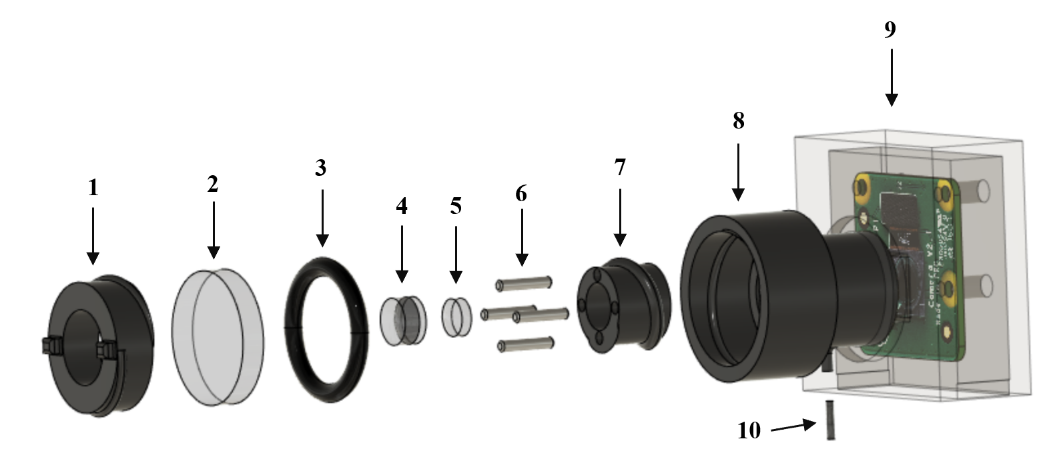

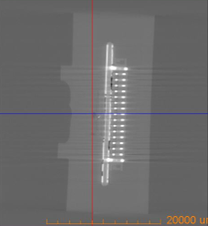 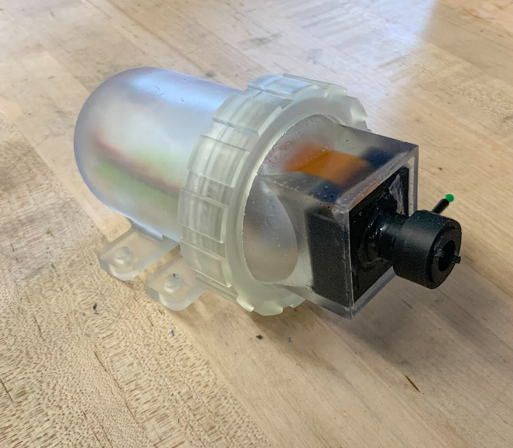

**Fig. 2.** (a) expanded view of PresTo (1) screw cap to hold the viewport in place (2) acrylic viewport (3) O-ring (4) achromatic lens (5) double convex lens (6) steel pins (7) lens holder (8) lens chamber (9) PCB/sensor case which is filled with clear epoxy (10) flexible tube for fluid compensation (b) X-Ray image of the epoxy potted case with the PCB and sensor (c) 3D printed assembly integrated with a 1-atm dry housing holding a Raspberry Pi Zero W and a battery

*3.2 Laboratory Results*

Comparison of the checkerboard photos between PresTo and DEEPi demonstrate that PresTo reduces underwater image distortions (Fig. 3). While images from PresTo have less contrast, resulting in a less sharp image, the checkerboard appears to be minimally distorted. The images from DEEPi look sharper, but the checkerboard appears to have undergone a pincushion distortion. This distortion gets worse closer to the edges of the frame. Values from the calibration matrices and distortion coefficients were also calculated for both cameras and can be found in the supplemental material. The distortion coefficients confirm that there is a pincushion distortion in the DEEPi images. Laboratory pressure testing shows that PresTo can function to a pressure of at least 27.6 MPa (~2700 msw). PresTo was exposed to this maximum pressure 3 times with no change to its functionality.

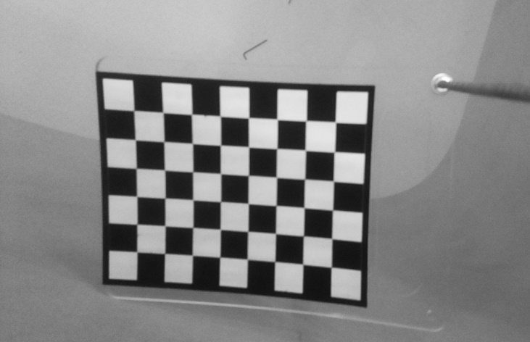 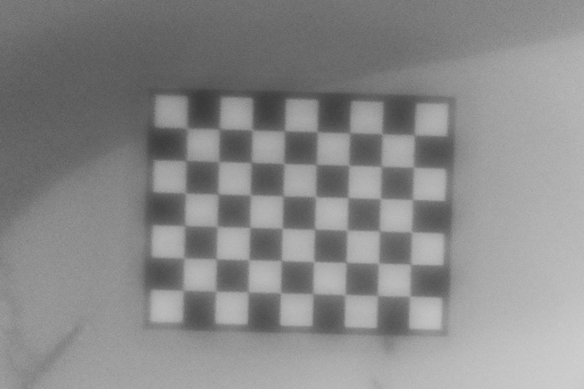**Fig. 3.** Photos of a 23 cm x 18 cm checkerboard taken underwater (left) with DEEPi, a traditional air-filled camera lens (right) with PresTo, a liquid-filled camera lens

*3.3 Field Results*

Shallow water deployments went to a maximum depth of 10 meters for 30 minutes. For deep-sea deployments, the self-contained system was mounted to a BRUV and recorded continuous video while at depth (Fig. 4a). The first deployment was at 1236 m for 6 hours, the second deployment was at 1423 m for 17 hours, and the third deployment was to 1722 m for 5 hours. The deep deployments measured an average temperature of 4.6 °C. During these deployments PresTo captured footage of several deepwater species such as a codling (*Antimora rostrata* Günther, 1878) and a bluntnose sixgill shark (*Hexanchus griseus* Bonnaterre, 1788).

**(e)**

**(d)**

**(c)**

**(b)**

**(a)**

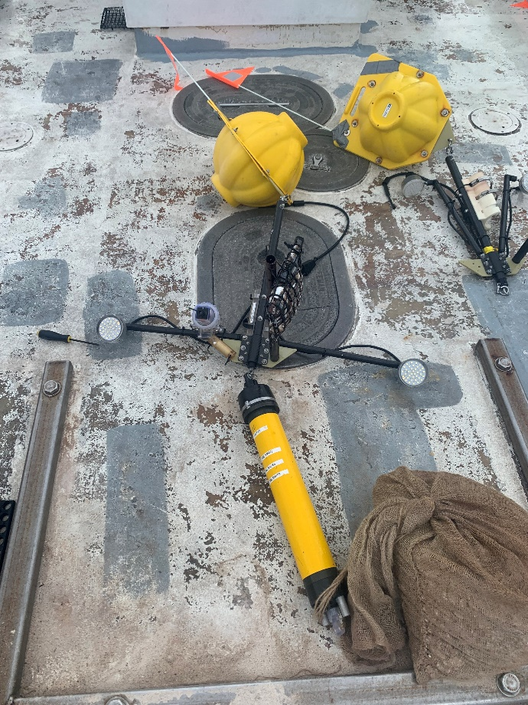 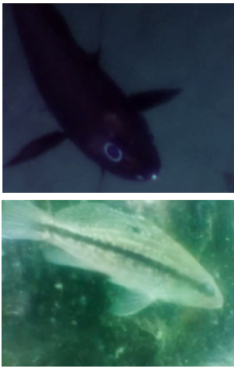

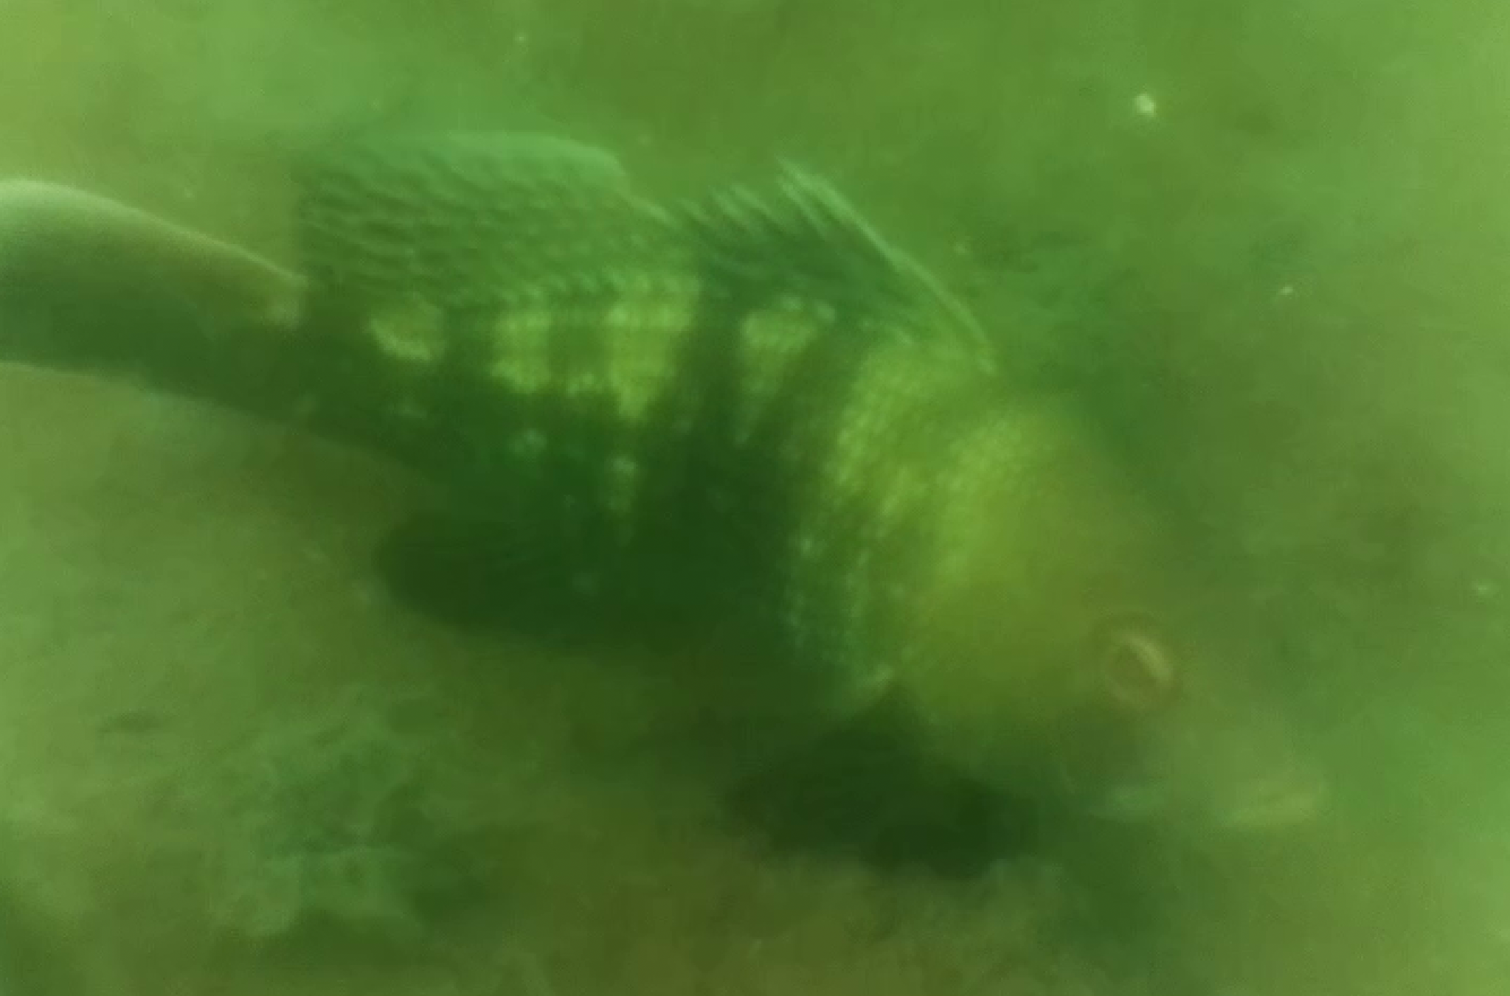 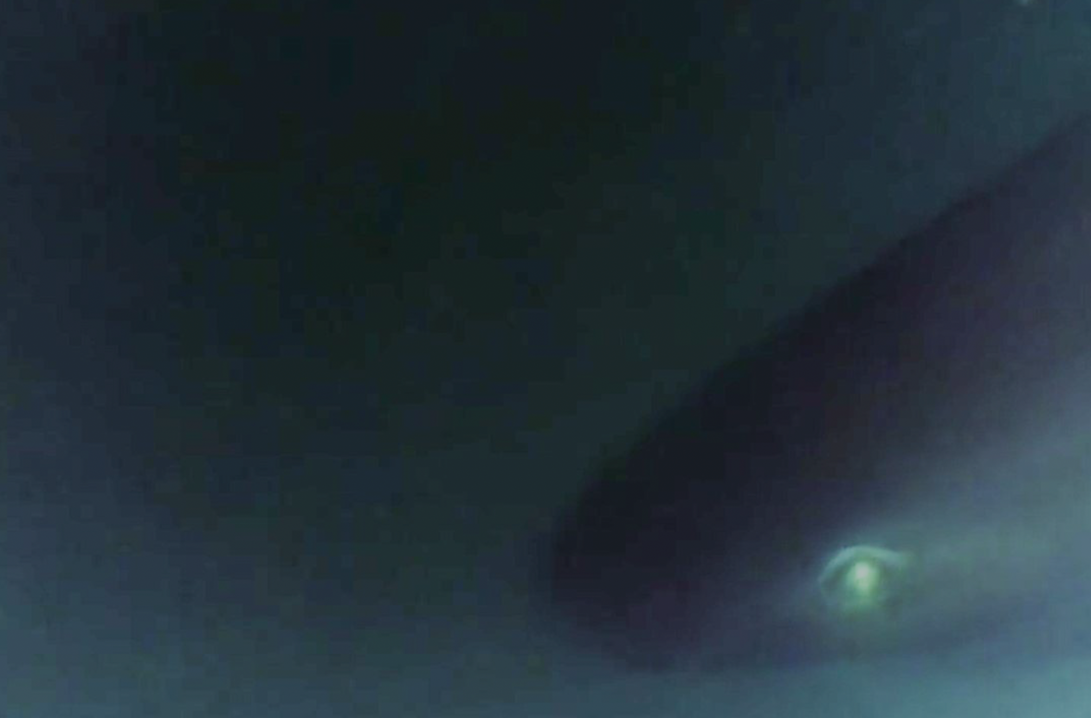

**Fig. 4.** (a) red arrow pointing to PresTo attached to a BRUV for deep-sea deployment in Bermuda (b) image of a codling (Antimora rostrata) taken at 1722 m depth (c) image of a juvenile black sea bass (Centropristis striata Linnaeus, 1758) taken at 10 m depth (d) image of a black sea bass (Centropristis striata) taken at 10 m depth (e) image of bluntnose sixgill shark (Hexanchus griseus) taken at 1423 m depth

**4. Discussion**

PresTo is a low-cost, pressure tolerant deep-sea imaging system. This design has the benefit of being easily customizable through manufacturing with 3D printing methods. There are many possible configurations of lenses for this design, but it is recommended to include an achromatic lens to maintain the focal length at varying depths. As ambient pressure on the system increases, there is a slight change in the IOR of the internal liquid which can cause a shift in the focal length of the system. (Gelze & Lehr, 2011; Millard & Seaver, 1990). Because the sensor and PCB are protected with epoxy, any liquid can be used to fill the lens chamber. Changing the liquid could allow the user to achieve longer or shorter focal lengths without buying more expensive glass lenses. Ethanol and isopropyl alcohol are other optically clear liquids that could be used in this design.

The magnetic focus mechanism allows for easy focusing without opening the lens chamber. This minimizes risk of damage to the lenses and sensor and doesn’t reintroduce air to the internal volume. This also provides the opportunity to create a zoom lens in future designs which is not available is previously made liquid-filled cameras. The overall assembly could also be adjusted to accommodate a different sensor if there is no protective piece covering the sensor which would contain an air gap. Using a larger, higher quality sensor could improve the field of view and sharpness of the image, however, the decreased sharpness of images taken by PresTo was most likely due to debris getting into the lens assembly and/or the lack of precision of utilizing 3D printing methods compared to traditional machined methods. This issue could be reduced by manufacturing the camera in a more sterile environment. Other optical variables, such as chromatic and spherical aberrations, need to be further investigated to improve the overall image quality of PresTo. The use of liquid in the optical assembly likely increases chromatic aberrations based on previous studies comparing chromatic aberrations in air versus in water (Helmholz & Lichti, 2020).

Filling the camera lens with a liquid with a similar IOR to the external medium, in this case water, presents a unique solution to the image distortions experienced by traditional underwater cameras with a flat viewport. By maintaining the optical ray path from the object to the sensor many of these distortions are mitigated. This reduces the need for a hemispherical dome port which is a substantial benefit due to the cost and manufacturing process associated with integrating dome ports into underwater housings. This is a significant improvement from previous designs of liquid-filled cameras as the imaging sensor in PresTo is protected from the internal liquid, thus the user can choose any liquid without needing to consider possible damage to the sensor. Because the lens assembly is pressure tolerant and does not require a housing, PresTo negates the need for a separate flat or dome viewport altogether. Another way to reduce image distortion is using calibration to correct the image, but this requires taking new calibration photos every time the camera is adjusted or changes focal lengths. Soft or curved photodetector arrays may also be used to mitigate image distortions and facilitate better epoxy bonding in future iterations of PresTo (Lee et al., 2018).

PresTo, in theory, can operate to full ocean depth which exceeds the pressure rating of almost every commercially available deep-sea camera apart from true abyssal-depth imaging systems such as DSPL’s 11km-rated HD Multi SeaCam ([www.deepsea.com](http://www.deepsea.com)). Further testing in a hydrostatic facility that can produce pressures beyond 30 MPa is required to verify this and was not possible within the scope of this study. PresTo was produced at a fraction of the cost of most underwater cameras despite their depth rating, with less than $300 in materials per prototype that was manufactured. The development of low-cost pressure tolerant cameras using 3D printed parts makes deep-sea research and exploration accessible to a broader range of marine scientists and engineers. PresTo can be deployed as a self-contained system, which makes it an easy addition to underwater vehicles, BRUVs, and other platforms. The design of PresTo may also be applicable to deep-rated stereo and multi-camera arrays that utilize short baseline separations. Currently such designs require separate housings for each camera, as each viewport must be symmetrically oriented to the interior lens, or somehow enclosed in a common pressure housing with complex reinforcing geometry.

**5. Conclusion**

This paper described the design and application of a low cost, pressure tolerant imaging system filled with liquid. This design can be modified to achieve different lens properties including zoom abilities. This camera has the advantage of minimizing image distortions that are common to traditional underwater cameras with a flat viewport. PresTo was tested to a maximum pressure of 27.6 MPa in a hydraulic pressure chamber. It was also deployed in shallow water in Rhode Island and in deep water in Bermuda to a maximum depth of 1722 m for 5 hours. PresTo is a self-contained system that can be used for a range of applications and customized to achieve goals in academia, defense, and commercial industry.

**Acknowledgements**

The authors would like to thank Oliver Shipley, Christine de Silva, Johann Becker, Michael Daeffler, and Phillip Parisi for their assistance with field deployments and Jason Noel and Brian Leong for their assistance with laboratory testing. We also thank Chris Roman for consulting on the design of the optical assembly. This work was funded by ONR award N00014-21-1-2656 with Bermuda based fieldwork activities supported by DarwinPlus Project No. 145.

**Appendix A. Supplemental Material**

Supplemental material was submitted in a separate file.

**References**Bradski, G. (2000). The OpenCV Library*. Dr. Dobb's Journal of Software Tools*.

Breddermann, K., Drescher, P., Polzin, C., Seitz, H., & Paschen, M. (2016). Printed pressure housings for underwater applications. *Ocean Engineering*, *113*, 57–63. https://doi.org/10.1016/j.oceaneng.2015.12.033

Cazenave, F., Kecy, C., Risi, M., & Haddock, S. H. D. (2015). SeeStar: A low-cost, modular and open-source camera system for subsea observations. *2014 Oceans - St. John’s, OCEANS 2014*. https://doi.org/10.1109/OCEANS.2014.7003077

Gelze, J., & Lehr, H. (2011). On the way to a pressure-tolerant imaging system. *OCEANS’11 - MTS/IEEE Kona, Program Book*, 2–5. https://doi.org/10.23919/oceans.2011.6106949

Helmholz, P., & Lichti, D. D. (2020). Investigation of chromatic aberration and its influence on the processing of underwater imagery. *Remote Sensing*, *12*(18). https://doi.org/10.3390/RS12183002

Holzschuh, J. E. (1978). A Pressure Tolerant TV Camera. *IEEE Journal of Oceanic Engineering*, *OE*-*3*(1), 22–27. https://doi.org/10.1109/JOE.1978.1145365

Kampmann, P., Lemburg, J., Hanff, H., & Kirchner, F. (2012). Hybrid Pressure-Tolerant Electronics. *Oceans*, 1–5.

Lee, G. J., Choi, C., Kim, D. H., & Song, Y. M. (2018). Bioinspired Artificial Eyes: Optic Components, Digital Cameras, and Visual Prostheses. *Advanced Functional Materials*, *28*(24). https://doi.org/10.1002/adfm.201705202

Lutus, P. (2017). *OpticalRayTracer* (9.6). https://arachnoid.com/OpticalRayTracer/#Downloads

Maas, H.-G. (1995). New developments in Multimedia Photogrammetry. *Symposium A Quarterly Journal In Modern Foreign Literatures*, *8*(3), 150–155. http://scholar.google.com/scholar?hl=en&btnG=Search&q=intitle:New+developments+in+multimedia+photogrammetry#0

Marshall, G., Bakhtiari, M., Shepard, M., Tweedy, J., Rasch, D., Abernathy, K., Joliff, B., Carrier, J. C., & Heithaus, M. R. (2007). An advanced solid-state animal-borne video and environmental data-logging device (“CRITTERCAM”) for marine research. *Marine Technology Society Journal*, *41*(2), 31–38. https://doi.org/10.4031/002533207787442240

Menna, F., Nocerino, E., Fassi, F., & Remondino, F. (2016). Geometric and optic characterization of a hemispherical dome port for underwater photogrammetry. *Sensors (Switzerland)*, *16*(1), 1–21. https://doi.org/10.3390/s16010048

Millard, R. C., & Seaver, G. (1990). An index of refraction algorithm for seawater over temperature, pressure, salinity, density, and wavelength. *Deep Sea Research Part A, Oceanographic Research Papers*, *37*(12), 1909–1926. https://doi.org/10.1016/0198-0149(90)90086-B

Mohammed, J. S. (2016). Applications of 3D printing technologies in oceanography. *Methods in Oceanography*, *17*, 97–117. https://doi.org/10.1016/j.mio.2016.08.001

Morgan, J., & Hanau, R. (1953). Introduction to Geometrical and Physical Optics. In *American Journal of Physics* (Vol. 21, Issue 9). https://doi.org/10.1119/1.1998721

Phillips, B., Shipley, O., Halvorsen, J., Sternlicht, J., & Gallagher, A. (2019). First in situ observations of the sharpnose sevengill shark (Heptranchias perlo), from the Tongue of the Ocean, Bahamas. *Journal of the Ocean Science Foundation*, *32*, 17–22.

Phillips, B. T., Licht, S., Haiat, K. S., Bonney, J., Allder, J., Chaloux, N., Shomberg, R., & Noyes, T. J. (2019). DEEPi: A miniaturized, robust, and economical camera and computer system for deep-sea exploration: A miniaturized deep-sea camera system. *Deep-Sea Research Part I: Oceanographic Research Papers*, *153*(June), 103136. https://doi.org/10.1016/j.dsr.2019.103136

Thiede, C., Buscher, M., Lück, M., Lehr, H., Körner, G., Martin, J., Schlichting, M., Krüger, S., & Huth, H. (2009). An overall pressure tolerant underwater vehicle: DNS Pegel. *OCEANS ’09 IEEE Bremen: Balancing Technology with Future Needs*. https://doi.org/10.1109/OCEANSE.2009.5278313

Treibitz, T., Schechner, Y. Y., Kunz, C., & Singh, H. (2012). Flat refractive geometry. *IEEE Transactions on Pattern Analysis and Machine Intelligence*, *34*(1), 51–65. https://doi.org/10.1109/TPAMI.2011.105

Vogt, D. M., Becker, K. P., Phillips, B. T., Graule, M. A., Rotjan, R. D., Shank, T. M., Cordes, E. E., Wood, R. J., & Gruber, D. F. (2018). Shipboard design and fabrication of custom 3D-printed soft robotic manipulators for the investigation of delicate deep-sea organisms. *PLoS ONE*, *13*(8), 1–16. https://doi.org/10.1371/journal.pone.0200386